# CS 255 System Design Document

## Michael Tekin

## Computer Science Department, SNHU

## CS 255: System Analysis and Design

## James Shinevar

## 8/15/21

## UML Diagrams

### UML Use Case Diagram

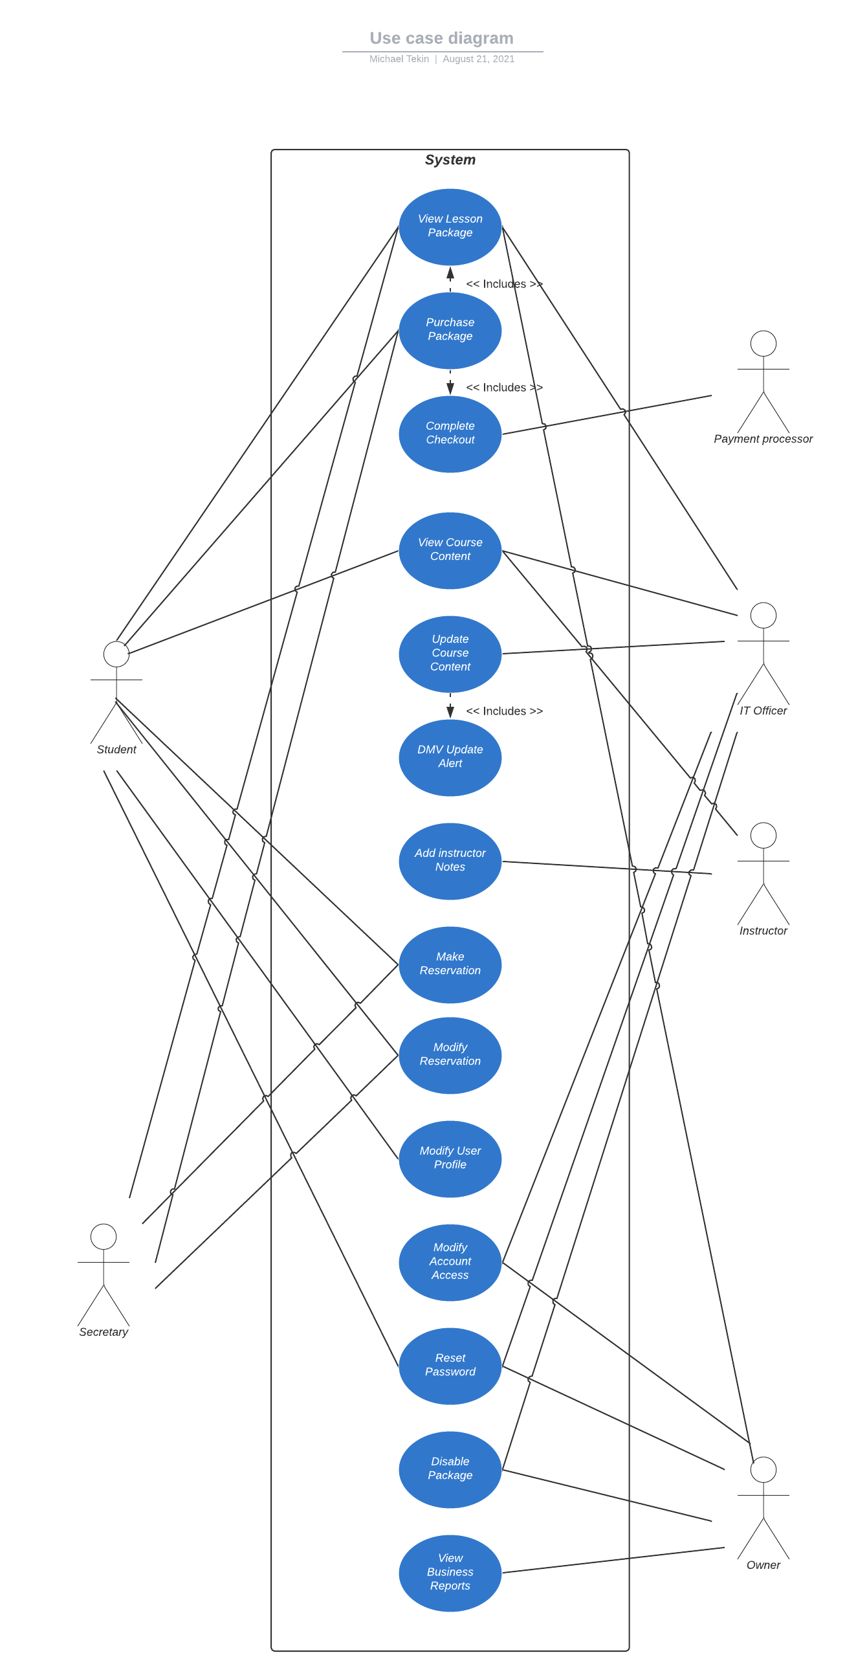

### UML Activity Diagrams

*Activity Diagram for creating a reservation*

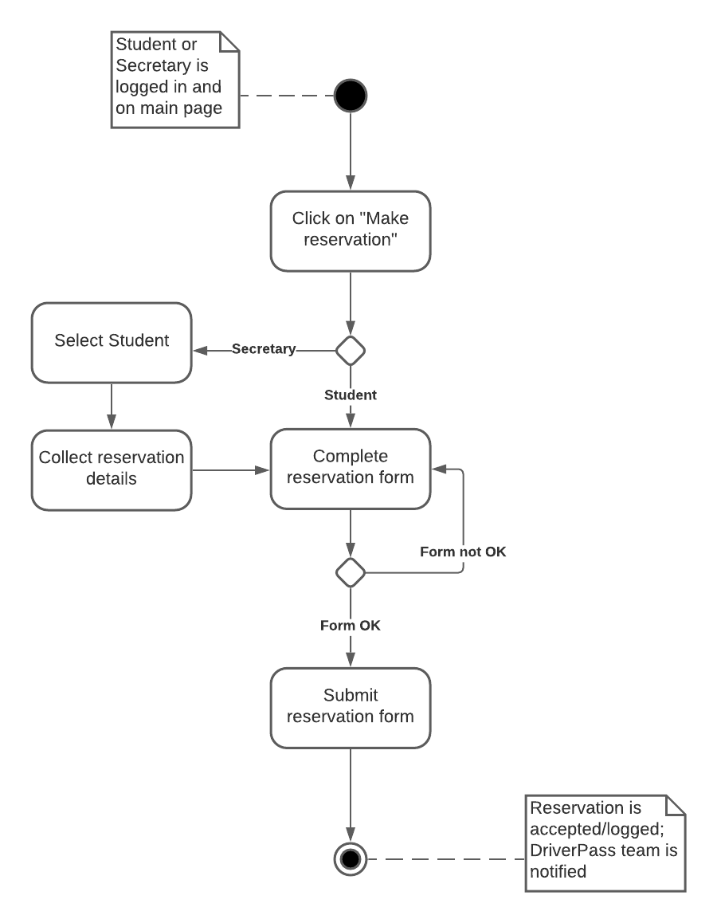

*Activity diagram for purchasing a lesson package / creating an account*

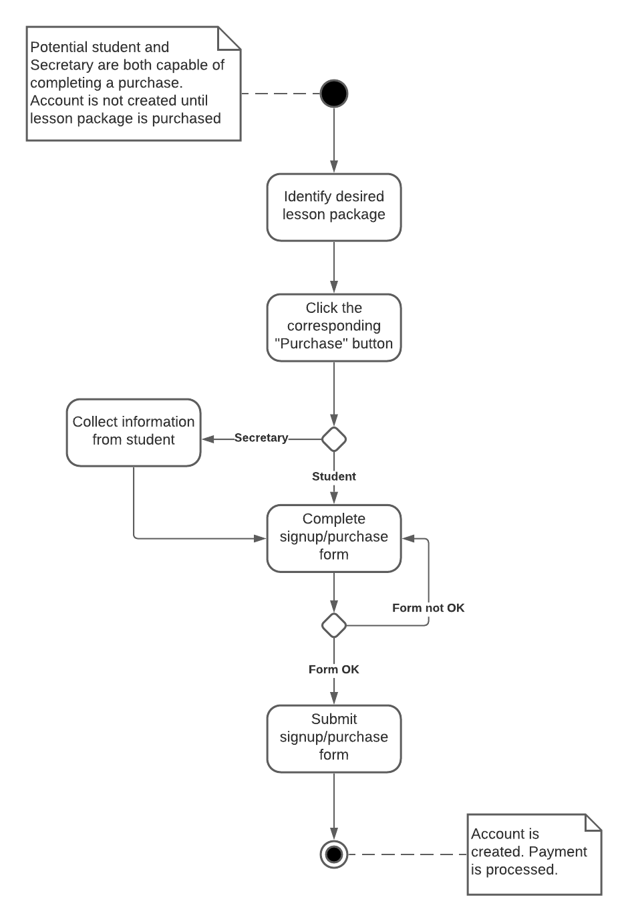

### UML Sequence Diagram

*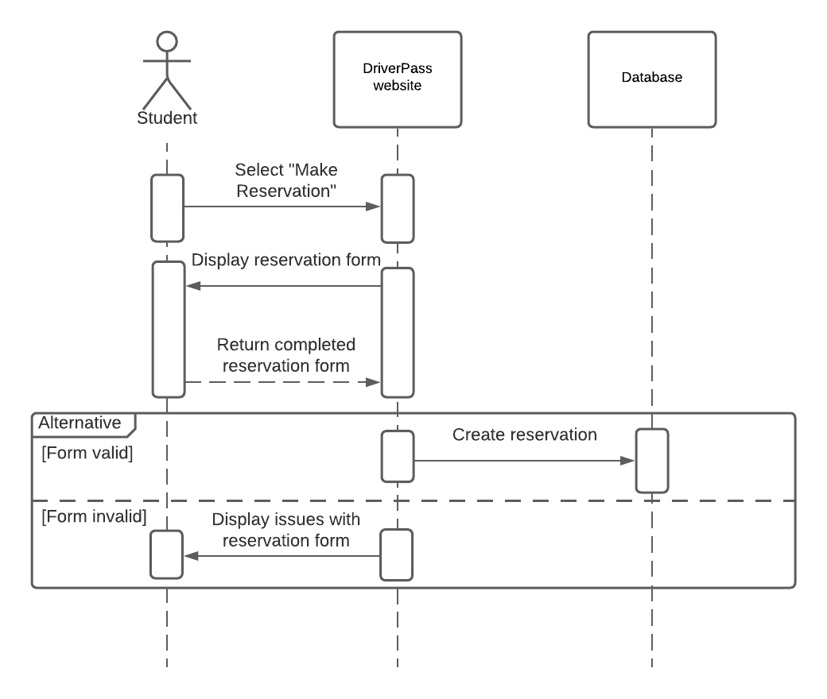***UML Class Diagram***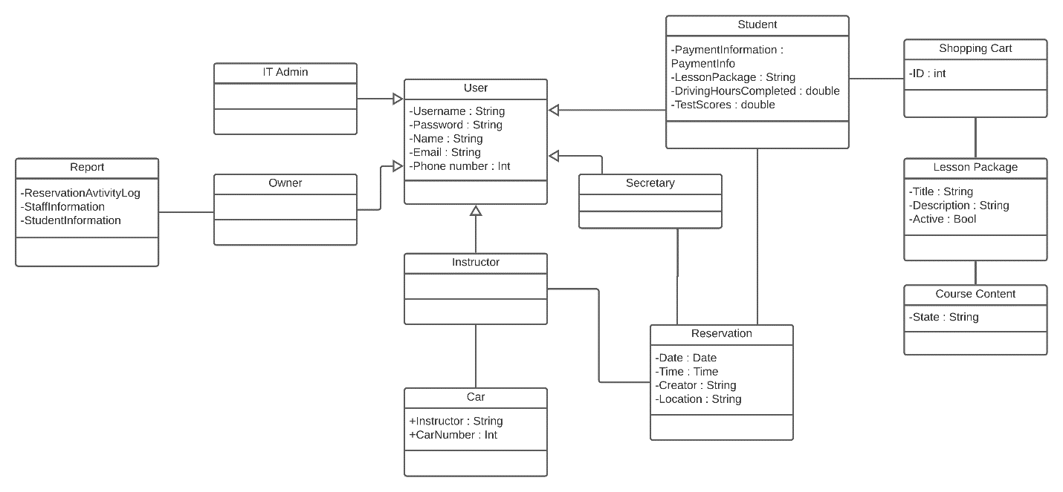*

## Technical Requirements

This system will be one designed for a web-based environment that needs to be trusted to remain up and running 24/7 except for scheduled maintenance. Hosting will be provided by a third-party cloud-hosting service like AWS who will handle backups and security on the server end. AWS also offers features that will allow us to manage usage and determine what it’s necessary to begin scaling up infrastructure. The hosting service will be making decisions on what hardware is needed. Software and tools needed will include: tools to help monitor website activity to identify potential and present issues like Zabbix, tools to help manage user-access levels like AWS identity and access management, a tool for managing bug reports and issue tracking like Jira, a tool for analyzing network traffic and identifying unexpected or unauthorized traffic like wireshark, and a tool for managing version control like bitbucket which supports Jira integration.